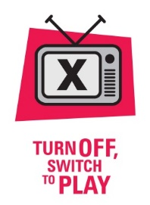
Turn Off and Switch to Play Action Plan

Criteria 5 Play equipment that encourages physical activity is made available to students at lunchtimes and other breaks.

Why is this criterion important?
Playtimes and lunchtimes provide important opportunities for children to engage in active play. Active play is defined as activity guided more by imagination than by fixed rules. Active play is a form of gross motor or total body movement in which children exert energy in a freely chosen, fun, and unstructured manner. Simply put active play is play using muscle groups. By providing play equipment, such as balls, skipping ropes and bats, and having interesting line markings in the schoolyard you may be able to increase students’ physical activity levels at playtimes.

To Do List
What  What action needs to be taken? (eg, equipment distribution plan, equipment purchase, active play line markings outside, involve students and staff) | How  How will it be done? (eg school assembly announcement, staff meeting, fundraising for play equipment)) | Who  Who will be responsible for organising the action? | When  When is it to be completed?
Use the following table to help plan what actions need to be taken to meet the criterion.
This is a Healthy Tasmania initiative 2017

Truelove S, Vanderloo LM, Tucker P. Defining and measuring active play among young children: a systematic review. Journal of physical activity and health. 2017;14(2):155-66.

