Sugar in Drinks
Classroom Activity

What students will learn:

- How to calculate the sugar content (grams and teaspoons of sugar) in a range of sweet drinks
- The difference between natural sugar and added sugar
- Why water and milk are the best drink choices.

What you will need:

- A packet of sugar cubes (or a bag of sugar and plastic teaspoons)
- Clear plastic cups
- A range of popular drink containers for example:

  - Water
  - Plain milk
  - Flavoured milk
  - 100% fruit juice
  - Fruit drink
  - Sports drink
  - Soft drink
  - Energy drink

Practical activity:

Arrange drink containers on a table.

Enquire:

- Ask students (without checking the nutritional information panel) which drink they think contains the most sugar? The least sugar?
- As a class, arrange the drink containers in the order of which they think contains the least-most sugar.
- Ask students to justify their reasons for ordering the drinks as they did.

Explore:

- Ask students to calculate the amount of sugar in each drink using the method outlined on the student handout.
- Measure out sugar cubes (or teaspoons of sugar) in clear plastic cups to make a visual comparison of the amount of sugar in each drink. Organise drinks from lowest to highest sugar content.
- Have a class discussion using the teaching notes over the page.

Teacher’s notes / key discussion points

Discussion questions:

- Were you surprised by the amount of sugar found in any of the drinks?
- Which drinks contain the most amount of sugar per serve?
- Which drinks contain the least amount of sugar per serve?
- How many serves are in each container? Found on the nutritional information panel).

Reinforce:

- Tap water and plain reduced fat milk are the best drink choices.
- Water is cheap and freely available, has no added sugar, artificial colourings or flavourings and helps protect against tooth decay.
- Our bodies need water to grow, think, play and be active.

Milk drinks:

- Plain milk contains a small amount of natural sugar (called lactose) and a range of other important nutrients such as calcium and protein.
- Flavoured milk contains both natural and added sugar.
- Plain milk is a better choice compared to flavoured milk as it contains no added sugar.

Fruit juice and fruit drinks:

- 100% fruit juice contains no added sugar, however it is very high in natural sugar because of the amount of fruit needed to make a glass of juice. For example there are 3-4 oranges in one glass of juice. Fruit juice is therefore very high in energy and not recommended as an everyday drink choice.
- Fruit drinks are a combination of fruit juice (must contain a minimum of 5%), water and added sugar. They are generally higher in sugar than 100% fruit juice as they contain both natural sugar from fruit juice and added sugar.
- Fruit juice is often thought to be a good choice because it contains vitamin C, however we can easily get our daily vitamin C from fresh fruit, for example ½ an orange.
- As well as containing large amounts of sugar, fruit juice and fruit drinks are also acidic which can increase tooth decay.
- It is best to eat fresh fruit and drink water as it:
  - is better for your teeth
  - gives you fibre to help keep you regular
  - is much more filling.
  - gives you energy to grow, think, play and be active.

Artificially sweetened drinks:

- Contain no sugar but are not recommended because:
- they are acidic and can cause tooth decay.
- they encourage a taste for sweet drinks rather than learning to enjoy water and plain milk.
- they are expensive compared to water.

Student/Class Handout 1: How much sugar are you drinking?

Use the information below to work out how much sugar is in each drink.

You could do this first example as a class.

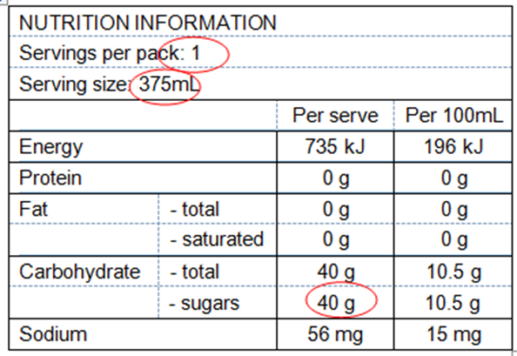

- Look at the nutrition information panel on this drink label.

- How many servings are there per pack? ____________

- What is the serving size? ________________________ ml

- Find the per serve column.

- Look at how many grams of sugar is listed in the per serve column (‘g’ means grams).

- There are __________ grams of sugar per serve in this drink.

- Divide this number by 4 grams (as 1 teaspoon of sugar or 1 sugar cube is equal to 4 grams).

- ____________ g ÷ 4 grams = ___________ teaspoons

This 375mL can of sweet drink has _________ teaspoons of sugar:

Student Handout 2: Select and Analyse

Select a drink container and use it to work through the following steps.

- Look at the nutrition information panel on the drink label.

- How many servings are there per pack? ____________

- What is the serving size? _________________________ ml

- Find the per serve column.

- Look at how many grams of sugar is listed in the per serving column (‘g’ means grams).

- There are __________ grams of sugar per serve in my drink.

- Divide this number by 4 grams (as 1 teaspoon of sugar or 1 sugar cube is equal to 4 grams).

- ___________ g ÷ 4 grams = ___________ teaspoons

There are __________ teaspoons of sugar per serve in my drink.

2017
This is a Healthy Tasmania initiative

This is a Healthy Tasmania initiative 2017

